**MINUTES OF TROSTON PARISH COUNCIL MEETING TUESDAY 1ST JULY 2025 7PM AT TROSTON VILLAGE HALL**

Cllr Bilverstone chaired the meeting along with Cllrs Riddick, Walton, Pugson

1 member of the public, the Clerk and West Suffolk Cllr Speed were also present.

1. Cllr Bilverstone welcomed everyone to the meeting and reminded everybody present that the meeting maybe recorded. No apologies were received.

a)i No Councillor declarations of interest were received. There were no updates to Councillors

register of members interest’s form.

a)ii No written requests for dispensation were received prior to the meeting.

1. **Co-Option of new Parish Councillor**

None

1. **Minutes**

The minutes of the Council meeting on Tuesday 14th January 2025 were agreed, approved and signed to stand as an accurate record of the meeting.

1. **Report from RAF Honington**

The Clerk reported that RAF Honington have not appointed a liaison Officer yet. The Clerk will continue to send the agendas and minutes.

1. **Meeting open for questions from the public – 15 minutes total**

Concerns were raised about the continued problem with dog fouling on the playing field and throughout the village. Discussions followed about more signage being displayed, free dog waste bags being available and keeping dogs on leads. Council agreed it was a problem and more signage would be placed around the playing field, they would explore the costs of the dog waste bags.

A request for a community garden on the playing field was made and discussion followed about water sources, position and who would manage, this item will be added to our next agenda.

1. **Village Hall report**

Brenda Burridge gave the report which advised:

Unfortunately, the grant request from the Lottery Fund has been unsuccessful. A survey of the roof will be carried out on Tuesday 11th March 2025 by Whitworth Surveyors at a cost of £495 plus VAT, their report will take approximately 10 days to process. Cllr Speed confirmed that funding from his locality fund would be available in the new financial year, Cllr Hopfensperger confirmed via email she would also be able to contribute. The Village Hall insurance has been renewed. New quotes for the outside lighting will be sourced. The Clerk confirmed that after funding is received from Cllr Hopfensperger for the acoustic tiles there will be £689 due from the Village Hall Committee as previously agreed.

1. **Council to consider any findings from the Village Hall report**

The Clerk confirmed that scanned copies of the complete leases had been obtained from Birkett’s Solicitors, Councillors decided to wait for the results of the surveyor’s report before any further discussion. The Parish Council thanked Brenda and the whole Village Hall Committee for all of their hard work during this stressful time.

1. **Report from County Councillor Rebecca Hopfensperger.**

Cllr Hopfensperger was unable to attend the meeting but had emailed a report and details on the following items

1. Grant for the SID/VAS – This will be available in from the locality fund in the new financial year. The Clerk will make an application.
2. Grant for acoustic tiles – This had gone missing but the Clerk can forward details again as this has been agreed and funds allocated.
3. Speed sign stickers – There were no updates on this item.
4. **Report from Borough Councillor Andrew Speed**

Cllr Speed gave a brief update on progress on Devolution, plans are being drawn up and need to be in place to met a deadline in September 2025. There is a mayoral consultation being carried out online, the mayor would cover the whole of Norfolk and Suffolk and he would encourage the Parish Council and residents to take part. He would liaise with John Cutmore about the village hall roof and confirmed he would have funds available in the new financial year to contribute. He also confirmed that he can award a £500 grant towards the new zipwire, the Clerk to complete all necessary forms.

1. **Finance**
2. The Clerk provided a schedule of payments which were agreed and approved unanimously.

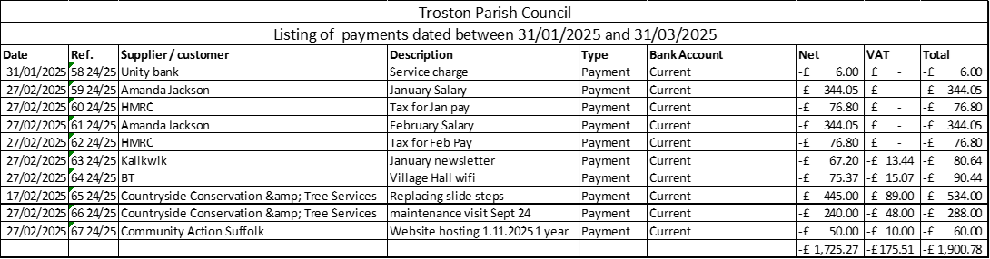

1. The Clerk had circulated the bank reconciliations and actual spend to budget reports. There were no questions.
2. Council discussed who to appoint as the internal Auditor for the 2024/25 audit and unanimously agreed to appoint Suffolk Association of Local Councils who completed the 2023/24 audit.
3. **Playground/playing field**
4. **To consider the playground inspection report and note any actions** – the Clerk advised there were not notes or actions to be taken, Councillors requested a copy of the report as it arrives. The Clerk will forward the most recent report.
5. **Update on the replacement slide steps project** – the Clerk confirmed that the steps had been replaced, they may take a few weeks to bed in.
6. **Update on goal sleeves project** – Cllr Pugson has researched and feels that a working party could install the goal sleeves at a much-reduced cost once the ground is a little softer. Councillors discussed and unanimously agreed with this method on a budget of £150.
7. **Council reviewed quotations from 3 suppliers to instal a 25m zipline** – The Clerk had circulated quotations for both steel and timber zipline options, Councillors discussed and felt the most cost-effective option would be a timber version from Online Playgrounds at a cost of £10,165 excluding vat. Cllrs asked the Clerk to clarity what the £485 cost in the quote for an independent post installation inspection was for. Councillors agreed to the zip wire being ordered when satisfied with the answer to the query. £5000 from the Community Asset grant from West Suffolk Council would be used along with a £500 grant from Cllr Speed. The glass recycling payment of £1096 will be put towards the cost. The remainder of the cost will be funded from the playground budget for 2025/26. the council agreed to the zip wire being ordered when satisfied with the inspection fee query?
8. **Village matters/maintenance**
9. **VAS Funding** - SCC R Hopfensperger confirmed via email funding of £940 will be awarded in the new financial year.
10. **Decommissioned phone box/seed swap** – Cllr Bilverstone advised the seed swap project was set up and running in the decommissioned phone box. Positive feedback has been received on the facebook page. It was noted that the phone box could do with a coat of paint.
11. **Village website update** – Cllr Pugson advised the Council of progress made on updating the website, these include that the Troston Economy page, the bios and the telephone box seed swap are all now live. The next stage will be sorting all the files into a sensible order along with a need for more photographs of the village, all photographs welcome.
12. **Troston Wood working group party date** – Council discussed and agreed on Saturday 22nd March for a working party at Troston Woods. Cllr Bilverstone will post on the village facebook page. It was agreed gloves and equipment would be useful. Cllr Moffat advised that he had planted a cherry, pear and apple tree in the woods near the hives. Councillors thanked Cllr Moffat for planting the trees.
13. **Clerks’ probation period completion** – Council noted that the Clerks 6-month probation period had ended and decided to feedback their decision by email later in the month.
14. **Councillors reports and items for future agendas**

Community garden

Entrance bollard opposite the pig farm

1. **Correspondence for action or information**
2. **Date of the next meeting**

The next meeting will be on Tuesday 6th May 2025 at 7pm. The first hour will be for the Annual Parish meeting followed by the Annual Parish Council meeting.