MINUTES OF TROSTON PARISH COUNCIL MEETING TUESDAY 5TH MAY 2026 7PM AT TROSTON VILLAGE HALL

Cllr Bilverstone chaired the meeting along with Cllrs Riddick, Pugson, Moffatt, Norris, Mouncey and Fletcher and the Clerk. 1 member of the public was present.

- Cllr Bilverstone welcomed everyone to the meeting and reminded everybody present that the meeting maybe recorded.
a)i There were no updates to Councillors register of members interest’s form.
a)ii No written requests for dispensation were received prior to the meeting.

- Approval of the minutes Tuesday 3rd March 2026
The minutes of the Council meeting on Tuesday 3rd March 2026 were agreed, approved and signed to stand as an accurate record of the meeting.

- Meeting open for questions from the public – 15 minutes total
There were no questions.

- Report from RAF Honington
The Clerk reported that RAF Honington have not appointed a community liaison officer but are hoping to later this year.

- Report from County Councillor Rebecca Hopfensperger.
Cllr Hopfensperger did not attend the meeting.

- Report from District Councillor Andrew Speed
Cllr Speed reported: Confirmed the governments decision in the local government reorganisation as the Power of Three option giving Suffolk 3 unitary authorities. Confirmation that the bottle banks will stay in place for the next couple of years and that the new bins will have started to arrive ready for the better recycling scheme starting in June 2026.

- Completed Planning Applications
West Suffolk Council had grant permission for planning application DC/26/0005/HH single storey infill extension on front elevation – The willow.

- Annual Village Meeting Tuesday 14th April 2026
Cllr Bilverstone ran through the agenda for the evening and proposed a budget of £100.00 to cover the costs of wine, on sale or return, soft drinks and nibbles. Seconded by Cllr Norris. Unanimously agreed. Cllr Norris will bring a flip chart and paper to record questions and ideas.

- Playground/playing field
- To consider the playground inspection report and note any actions.
Councillors discussed and agreed to move forward with the following maintenance:
To purchase the grass matting squares to repair the eroded area by the double gates.
To stabilise the steps to the slide with additional soil.
To sand and paint the Multiplay fort with Hammerite coating.
To clean and treat equipment to clear the algae.
Cllr Bilverstone proposed a budget of £150 for the maintenance, seconded Cllr Pugson. Unanimously agreed. The Clerk will look at costs to replace the basket of the basket swing.
Council discussed creation of a 5-year plan for renewal of the equipment in the children’s
playground and the on the playing field. This will be for a future agenda.

- Biodiversity/environmental updates for the playing field.
Cllr Bilverstone suggested that once feedback from residents at the Annual Parish Meeting of the Electorate on 14th April had been received a plan would be put together for discussion at a future meeting. Cllr Pugson clarified how the space allocation plan supplied at the March meeting worked.

- Village matters/maintenance
- To receive any updates regarding Troston Woods
Cllr Pugson updated Council on the work carried out with volunteers at the wood on 21st March 2026 actions taken:
Tidy up of steps at entrance
Paths at entrances strimmed back and widened
Removal of some lower dead branches in the area around the square table
Some paths around the square table area edged with the fallen branches
Paths generally cut back
Brambles cut back
Litter picked up along the road between the two main entrances
Cllr Pugson advised that 2 bags of 20mm stone are required to finish the steps, council agreed to £50. Cllr Bilverstone proposed, seconded by Cllr Pugson. Unanimously agreed.
At the next visit attention will is required on treatment of the sculptures.
Councillors thanked residents for their help and looked forward to their next visit on Saturday 18th April.
It was noted that an area of the wood which is believed to be outside the boundary was being used as dens had been built.

- To consider repairs to village signs and set a budget
Council discussed the maintenance of village signs. Cllr Bilverstone proposed a budget of £30 to treat and repaint the village sign outside the Bull Pub, seconded Cllr Fletcher. Unanimously agreed.

- To consider the purchase of fluorescent jackets
Council considered the purchase of 2 fluorescent jackets to be worn when the Vehicle Activated sign is transferred. Cllr Riddick proposed a budget of £15, seconded by Cllr Fletcher. Unanimously agreed.

- Council to decide on grass cutting start date
Council considered a start date for the contractor to cut the grass. It was agreed that conditions were right to start the season. The Clerk confirmed that she had had a meeting with the contractor to advise that the grass should be cut a level higher on the mower, an area of approx. 200mm will be left around any structure and to make then aware that the 60 hedge saplings had been planted.

- Finance
- The Clerk provided a schedule of payments which were agreed and approved unanimously.
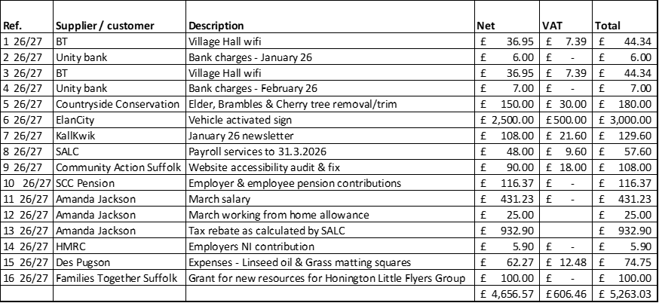
- The Clerk had circulated bank reconciliations prior to the meeting for both Current and Savings accounts which unanimously agreed and approved.
- Council reviewed the actual spend to agreed budget for 2025/26 athere were no questions.
- Council reviewed expenditure over £100 for 2025/26 and there were no questions.
- Clerks and Responsible Financial officer report:
- Interest earned for 2025/26 from the savings account £407.75
- The hole on the pavement outside the Bull Pub has been repaired
- SALC now offer an Human Resources Advice Service as part of the subscription
- An extension to the pole is required to mount the new Vehicle Activated sign to at a cost of £630.00 for supply and installation by Suffolk County Council.

- Council to review the website accessibility report and action by One Suffolk
Council reviewed the website accessibility report commissioned by One Suffolk that was circulated prior to the meeting showing the repairs that were made to the website to become compliant. There were no questions.

- Council to consider changing website and email hosting supplier
Council discussed a report prepared by the Clerk and circulated prior to the meeting. It was agreed that our current website is not very flexible or easy to read and locate information. Councillors agreed as a first step to arrange a meeting with Suffolk Cloud to explore their offerings. The Clerk and Cllrs Pugson and Bilverstone to attend.

- Update on Community Capital Grant application from West Suffolk Council
West Suffolk Council advised that on this occasion the Parish Council has not been successful in an award of a grant it had planned to renew the noticeboard and purchase an info board for the woods.

- Councillor reports and items for future agendas and Correspondence for action or information
- Cllr Riddick advised that the wooden slat bench by the phone box had a broken slat and needed attention. Cllr Bilverstone will see if a volunteer in the village could help with a repair.
- Cllr Norris advised that use of the noticeboard inside the bus shelter be added to our next agenda.
- Cllr Norris advised that for the last 15 years there has been no sign to Troston at the junction Barton Bottom and Livermere Road and would like adding to the next agenda.
- Cllr Norris advised of correspondence received about the Lower Farm development, the Clerk advised that the resident should feed their comments on West Suffolk Planning Portal.
- Lower Farm Parish Council comments, Councillors agreed to add to the next agenda where comments can be formulated from feedback at the Annual Parish Meeting of the Electorate on 14th April although they are not official consultees on this application.
- Cllr Pugson noted the repeater sign that was discarded in brambles still has not been replaced.
- Vehicle Activated Sign extension pole and installation £630.
- Cllr Moffat advised that as he is moving out of the village, he will no longer be a Parish Councillor. Cllr Bilverstone thank him for service to the village whilst on the Parish Council and all Councillors wished him well.

- Date of the next meeting
Annual Parish Council meeting - Tuesday 5th May 2026 at 7pm

There being no further business the meeting closed at 9.15pm.

