MINUTES OF TROSTON ANNUAL PARISH COUNCIL MEETING

Tuesday 1st July 2025 7.30pm at Troston Village Hall

Present: Cllrs D Bilverstone, P Walton, P Riddick, D Pugson, the Parish Clerk and 2 members of the

public.

**1. Election of Chairman**

1. Cllr Walton nominated Cllr Bilverstone for the role of Chairman. This was seconded by Cllr Riddick. Cllr Bilverstone accepted the position. Agreed by all.
2. The Chairman completed their Declaration of acceptance of office.
3. Election of Vice Chairman - Cllr Walton nominated Cllr Riddick for the role of Vice Chairman. This was seconded by Cllr Moffat. Cllr Riddick accepted the position and signed the Declaration of Acceptance of Office.
4. There were no updates to Councillors register of members interest’s forms
5. To appoint a responsible financial officer and internal auditor of our systems – Council appointed Amanda Jackson Parish Clerk as their Responsible Financial Officer. Councillor Pugson will be responsible for our internal reviews of systems.

**2. Apologies for absence**

Apologies were received and accepted from Cllrs Hopfensperger and Speed.

**3. Members Declarations of Interest and Dispensations:**

a) To receive declarations of interest from Councillors on items on the agenda - None

b) To receive written requests for dispensations for disclosable pecuniary interests - None

c) To grant dispensations as appropriate under Section 33 of the Localism Act – None

**4. To sign the minutes of the council meeting on Tuesday 4th March 2025 and the extra ordinary**

**council meeting on Monday 14th April 2025 to stand as an accurate record of the meeting**

The minutes of the meetings held on 4th March and 14th April 2025 were unanimously approved by those present and signed.

**5. Report from RAF Honington**

The Clerk reported that a new Community liaison Officer is due to be appointed in the next couple of weeks.

**6. Meeting open for questions from the public – 15 minutes total**

A resident asked why there were only 6 meetings a year and could there be more to help speed up decisions and actions. To help with community engagement it was felt that the newsletter should be printed for all properties rather than relying on the village facebook page and the noticeboard to share information. The Clerk will look at the cost implications for both and report back to Council. A concern was raised about low hanging branches from a tree on the corner opposite the pub, the Clerk will check if this is a highways issue or requires a letter to the occupants. A resident asked about the locations and rotation of the speed camera sites, Cllr Walton advised he would manage the sites frequency. **Action Clerk/Cllr Walton**

**7. To receive County Councillor’s report from Rebecca Hopfensperger**

Cllr Hopfensperger was unable to attend the meeting but sent the following report:

Local Government Reform

I've already explained talked to the council about this at previous meetings but just to recap, the government have decided to push the agenda for devolution and local government reorganisation in Suffolk. With regards to devolution Suffolk and Norfolk were successful in being accepted onto the Devolution Priority Programme which will mean the creation of a county combined authority of Suffolk and Norfolk which will be governed by a mayor. The likely powers the mayor will have will be strategic transport, population health, potentially blue light services and economic development. Running alongside this there will be a local government re-organisation which is formation of unitary council/councils in Suffolk and Norfolk. There will elections for the mayor in May 2026. The government asked councils in Norfolk and Suffolk to submit interim business cases of what unitary structures can look like in the areas by the end of January. Suffolk county council submitted a business case for one unitary Suffolk and the districts and borough put one in on multiple unitaries with either two or three but have since come out in favour of three. We have since heard from the government that all proposals will be asked to be developed into a full business case to be submitted to government by the end of September, I've attached the press release and full feedback from the government to this e-mail.

Highways Reporting

If anyone has any highway issues, I suggest that they use the highway reporting tool on SCC website but if they feel that they are not getting the answers they expect they can report it to the clerk and then I can chase and escalate the issues.

Locality Budget and Highways Budget

Just to remind any community group that have locality budget that can be used in the village, in the past I've supported the village hall, parish council and the church and also various highways projects.

**8. To receive District Councillor’s report from Andrew Speed**

Cllr Speed was unable to attend the meeting.

**9. Council to confirm the contract for the new Clerk as permanent following probation period**

Council confirmed that the Clerks contract is permanent.

**10. Council to agree the following resolutions, following Unity Trust Guidelines and**

a) add Councillor Paul Walton as a bank signatory to view, verify and release payments

b) to remove S Rose as a bank signatory

c) Council to resolve to complete these changes and that they have read and acknowledged the terms and conditions for the bank accounts, agreed to the telephone and internet banking declaration and have agreed to the declaration on the summary of Changes form.

Council discussed and Cllr Riddick proposed adding Cllr Walton as a signatory, removing S Rose and that they understood the terms and conditions of Unity Trust Bank seconded by Cllr Bilverstone. **Action Clerk**

**11. Finance**

a) To approve and sign the payments. The Clerk provided a schedule of payments which were agreed and approved unanimously. Cllr requested that a log be kept to track the grassing cutting and maintenance task. **Action Clerk**

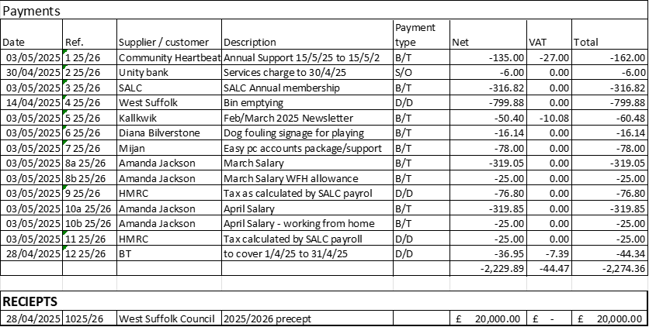

b) Financial report from the Responsible Financial Officer. The Clerk had circulated the bank

reconciliation, there were no questions. Cllr Bilverstone signed Council approval.

c) To review the actual spend to budget report circulated. The Clerk had circulated the actual spend to

budget report for 2024/25. There were no questions.

d) Council to note that the VAT reclaim has been received. The Clerk confirmed receipt of reclaimed

VAT.

e) Annual review of reserves and earmarked funds. Cllr reviewed the circulated report of earmarked

funds and had no questions.

f) Council confirmed completion of internal control review by Cllr Bilverstone. There were no

questions.

g) Council to consider quotation for replacing the battery on the speed camera. Cllr Walton advised the battery is working well so this has not been actioned.

h) End of year accounts

i. Council considered the report from the internal auditor showing that the accounts were found to be in good order, and we received positive feedback overall and the Councillors were happy to accept the internal audit report There were some suggestions made to reflect governance good practice, these included a review of the Standing Orders to update procurement thresholds, a review of the Financial Regulations as NALC had advised changes in March 2025, that we should annually review and agree the insurance cover as being adequate, to ensure that the Parish Council formally reviewed the scope and effectiveness of its internal audit arrangements, evidence approval of the Asset Register is correct, as our website is new we need to complete an up to date test of the site and document this within its Accessibility Statement.

ii. Council considered, approved and signed section one, Annual statement of the 2024/25 AGAR

Cllr Bilverstone proposed approval of section one, Annual Statement of the 2024/25 AGAR, seconded by Cllr Walton. Unanimously agreed.

iii. Council to considered, approved and signed section two, Accounting Statement of the 2024/25 AGAR

Cllr Bilverstone proposed approval of section two, Accounting Statement of the 2024/25 AGAR, seconded by Cllr Walton. Unanimously agreed.

iv. Council confirmed the dates for the exercise of public rights to approve the accounts are 3/6/2025 to 14/7/2025.

v. Council considered the statement of variances supplied by the Clerk, there were no questions.

vi. Council reviewed and approved the Annual Bank reconciliation, there were no questions.

vii. Council confirmed that the AGAR is complete and can be submitted to External Auditor.

**12. Good Governance – continuing Procedural items for the Councils Annual Meeting:**

i. Council considered renewing by resolution the approval of the use of variable direct debt to pay West Suffolk council for bin emptying, Information Commissioners Office (data protection), HMRC PAYE, BT and the use of a fixed Standing Order for the Clerks salary. Unanimously agreed.

ii. Council agreed to postpone the review of the Asset Register to a future meeting.

iii. Council agreed to postpone the review of insurance cover and comparison against the asset register to confirm Council are adequately insured to a future meeting.

iv. Council conducted its annual review of policies. There were no amendments to the Privacy policy but Council agreed to change its Complaints policy to a simpler version supplied by the Clerk. The Clerk will upload to the website. Proposed by Cllr Bilverstone, seconded by Cllr Moffat.

v. Council conducted its annual review of the Code of Conduct policy and on the advice of the Clerk and Suffolk Association of Local Councils changed to the LGA Code of Conduct. Proposed by Cllr Bilverstone, seconded by Cllr Riddick.

vi. Council conducted its annual review of Standing orders and Financial regulations and due to recent changes postponed the review to a future meeting.

**13. Playground/playing field**

a) Council considered the recent playground inspection report and Cllr Riddick confirmed he had walked through the playground and found all was okay. It was bought to the attention of the Parish Council that the fort had been roped off. The Parish Council will investigate.  **Action Clerk**

b) Zipwire Installation. The Clerk advised that the zipwire should be installed in the last 2 weeks of May. Cllr Pugson reminded all that the Troston Wood Work Party would like to use the some of the lengths of wood from the old zipwire to line the path at the woods.

**14. Village matters/maintenance**

a) Cllr Pugson gave an update on works at Troston Wood. The 8-month schedule of works will be shared with the Clerk and Councillors. The plan being to hold more work parties thought out the year. The Clerk reminded all that due to our insurance conditions work should be carried out as part of the working party days.

b) Cllr Pugson advised he has removed S Rose, created an events page and has been working on a famous resident of Troston page. There are some new photographs and will be starting on reformatting the site next.

c) Council discussed if a community garden would be a viable project in the village. Council agreed that there should be a village consultation to establish interest this will be discussed at the next Council meeting, in the meantime Cllr Bilverstone agreed to research further. **Action Cllr Bilverstone**

**15. Councillors reports and items for future agendas**

Cllr Walton felt it would good to supply a copy of the ‘Troston’ book to all homes in the village. This will be added to our next agenda. Cllr Walton asked if the funds had been received from Cllr Hopfensperger for the vehicle activated sign, funds had not yet been received. Cllr Pugson advise that he had washed the road signs, Cllr Bilverstone thank him.

**16. Correspondence for action or information**

None

**17. Date of our next meeting**

The next meeting will be on Tuesday 1st July 2025 at 7pm.